**WS39 - EXAM REVIEW**

**DATE: 02th march 2022**

Strategy pattern:........../10 SortingContext (sort(), setSortingStrategy()), SortingStrategy (interface sort()), BubbleSort sort(), IInsertionSort sort(), QuickSort sort() 7:40-7:45

GUI:.............................../10 ease of data input -> size, elements, or elements 7:45-7:57

working algorithms:...../10 2,1 -1, -5, 10, 0, 100 7, 8, 1, 2, 4, 0, -1, 3

……………………………… BubbleS 1,2 (4) InsertionS -5, -1, 0, 10, 100 (4) QuickS -1, 0, 1, 2, 3, 4, 7, 8 (4)

2,1 1,5,8,0,9 7,8,1,2,4,0,1,3

BS > 1,2 IS > 0,1,5,8,9 QS > 0,1,1,2,3,4,7,8

8:03 - 8:15

Clean code/principles:./10 variable and method names -> lowerCamelCase, Class ->

UpperCamelCase, good names, packages, utils,

main -> no code to sort, no code to store in the database

8:20 - 8:25

JSON MongoDB:........../10 yes/no 8:25 - 8:30

__________________________

TOTAL /50

Strategy pattern

GUI

working algorithms

Clean code/principles

JSON MongoDB

15 CRUZ PANTOJA DARLING MICAELA

Inspector: Kerly Correa

Strategy pattern: 9/10

GUI: 10/10

working algorithms: 7.5 /10

Clean code/principles: 10 /10

JSON MongoDB: 7/10

__________________________

TOTAL 43.5/50

Strategy pattern

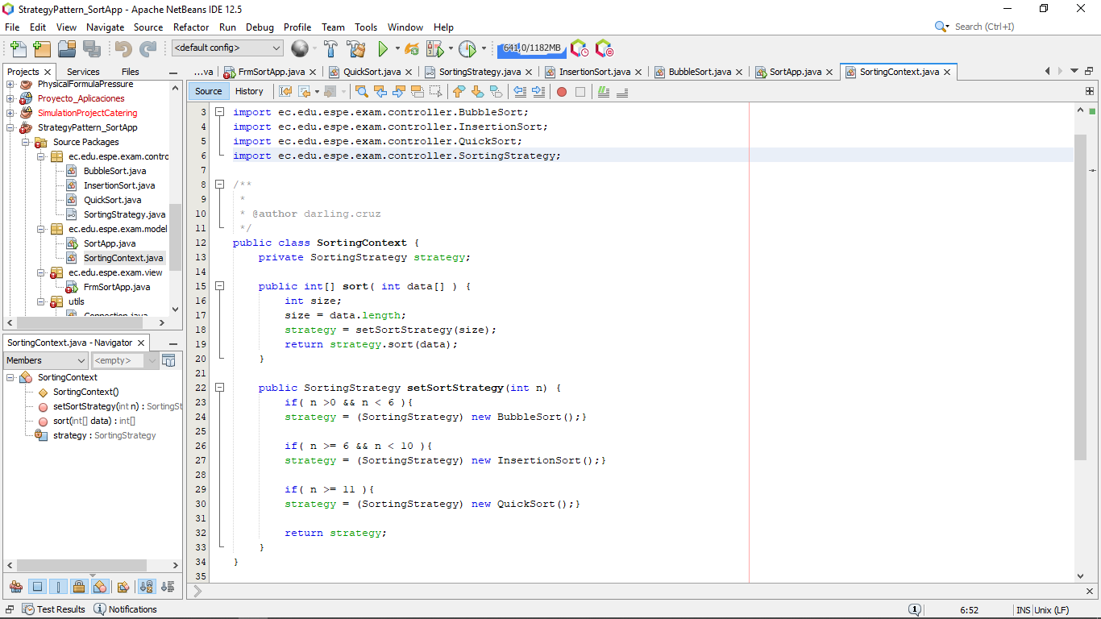

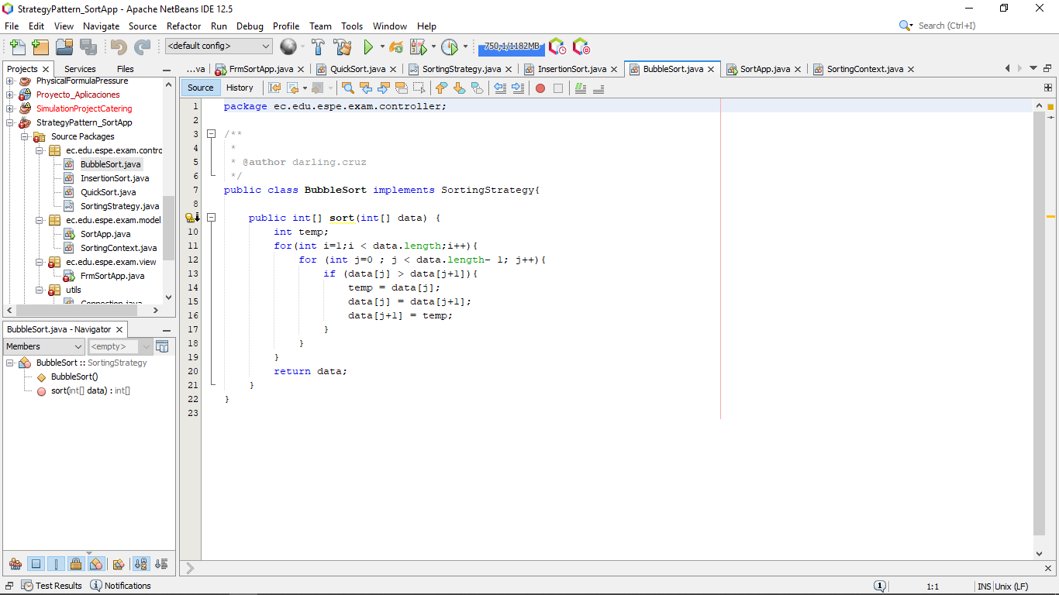

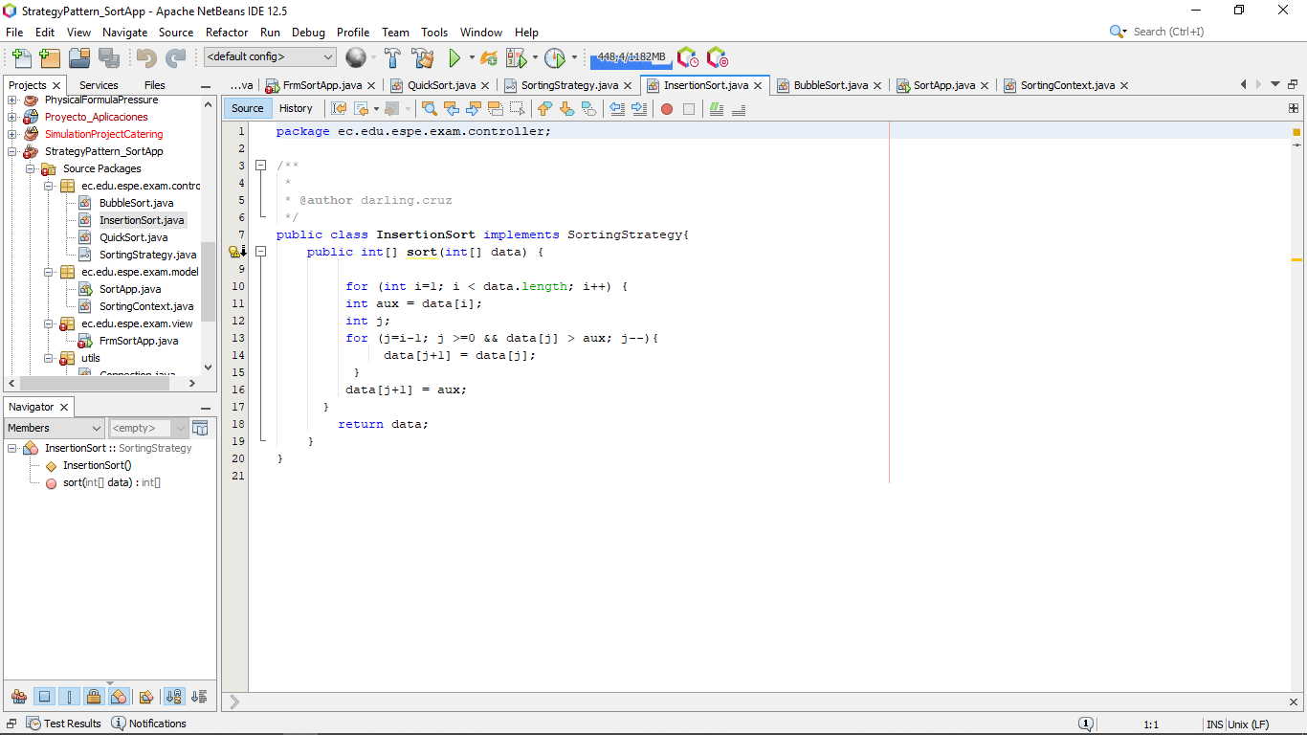

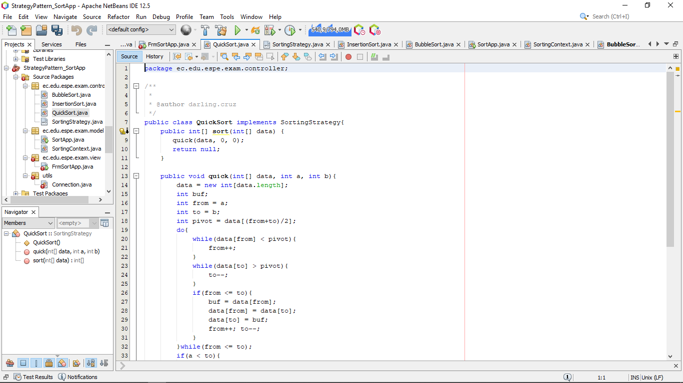

GUI

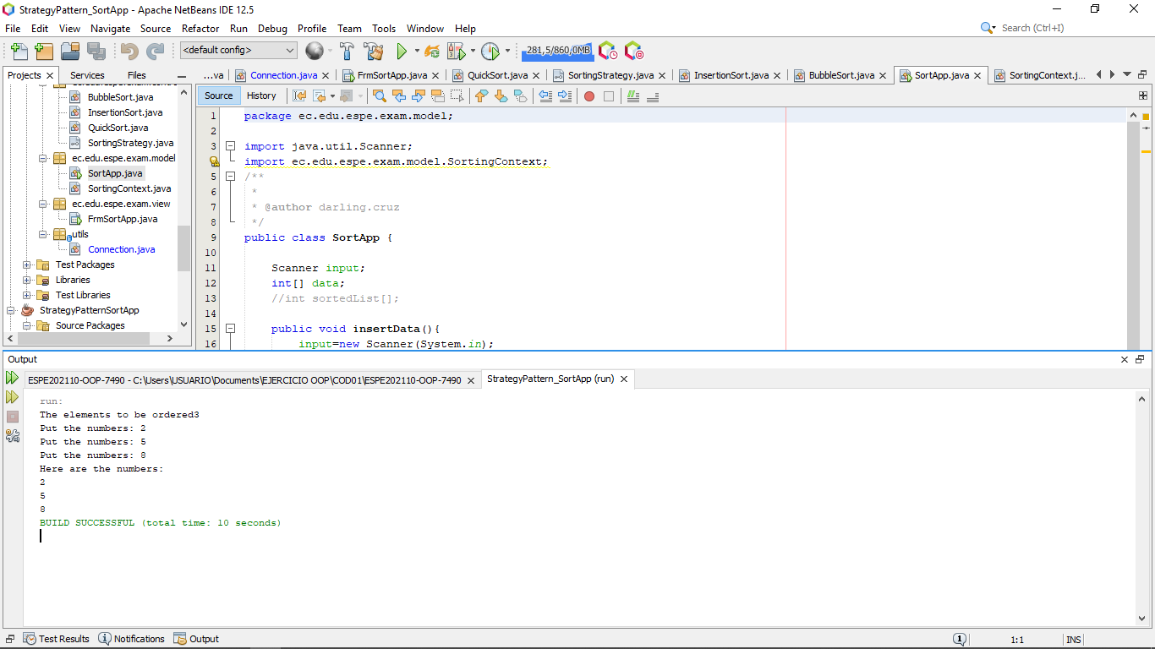

working algorithms

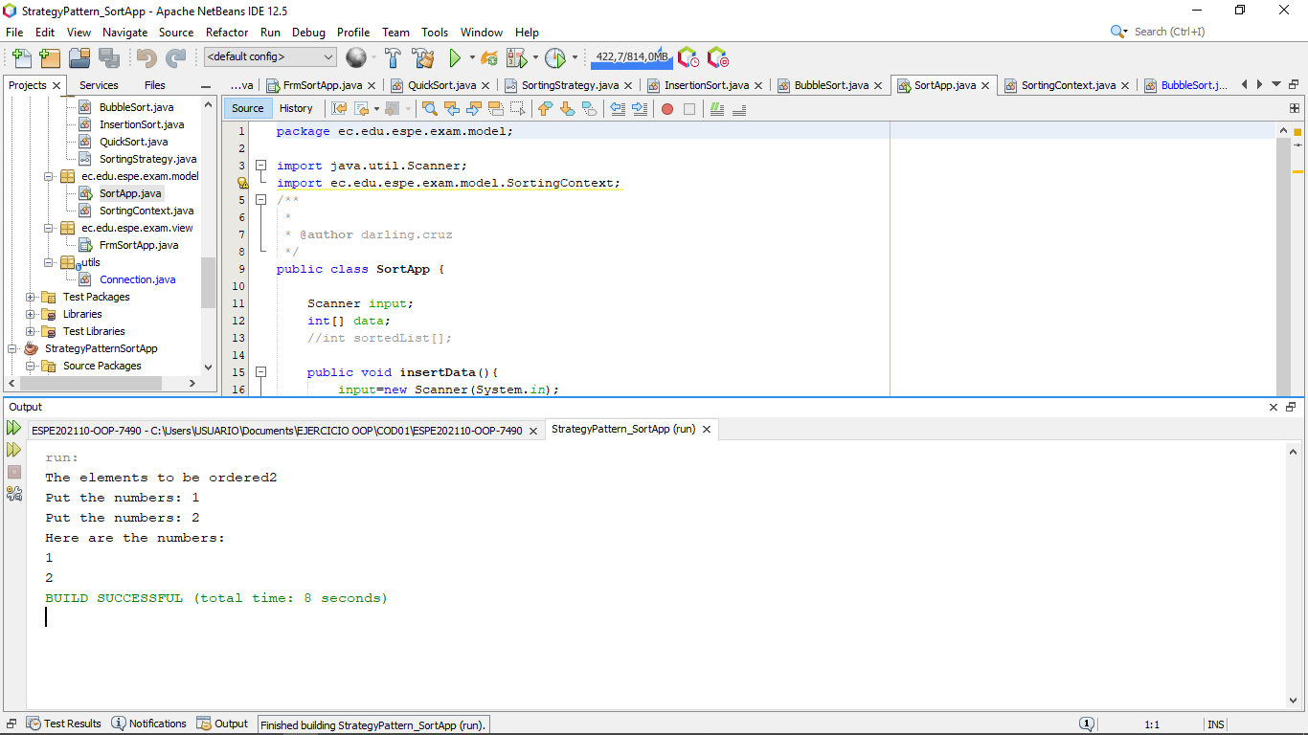

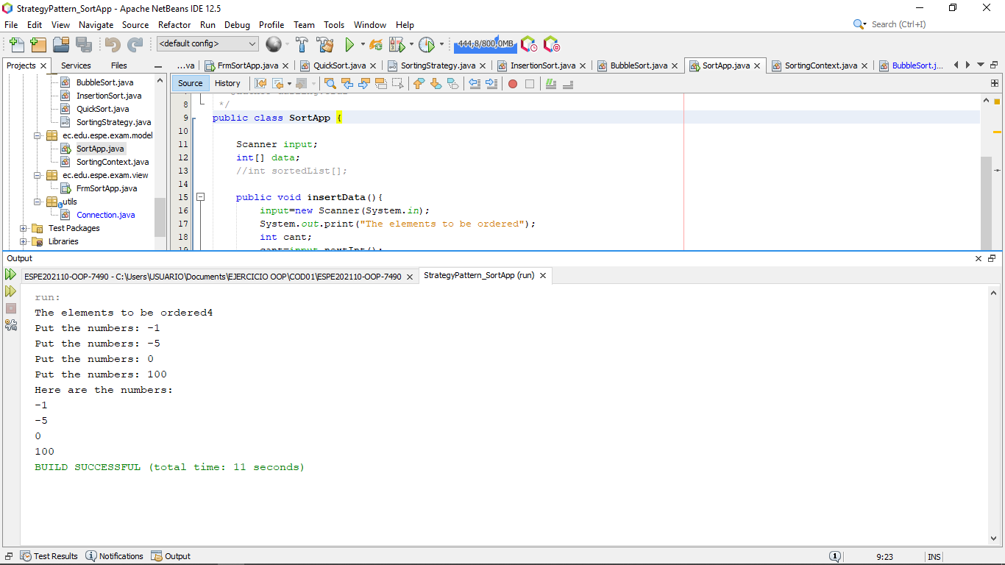

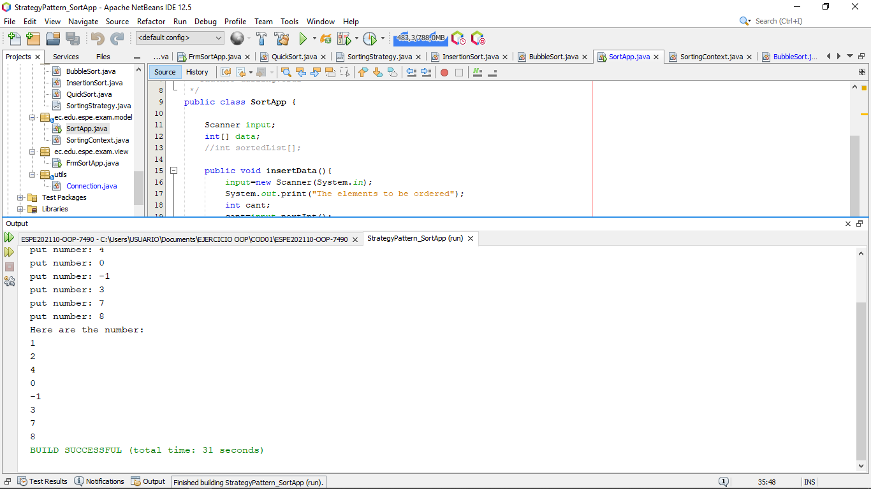

does not order

Clean code/principles

JSON MongoDB

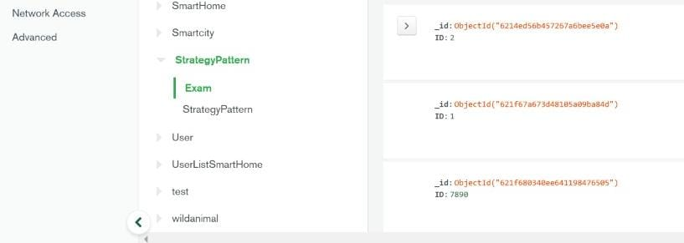

16 DE LA CRUZ QUINGA ALEJANDRO SEBASTIAN

Inspector: Darling Cruz

Strategy pattern:.......... 10 /10

GUI:............................... 10/10

working algorithms:..... 8/10

Clean code/principles:.10/10

JSON MongoDB:..........7/10

__________________________

TOTAL 45 /50

Strategy pattern

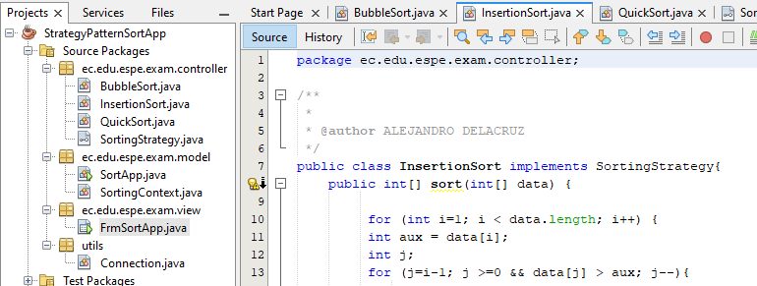

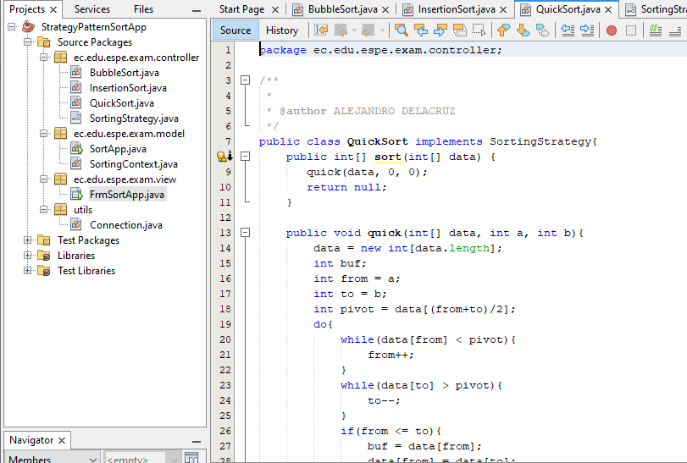

GUI

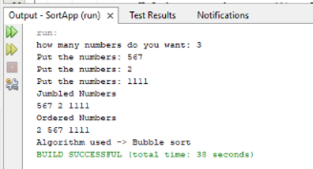

Working algorithms

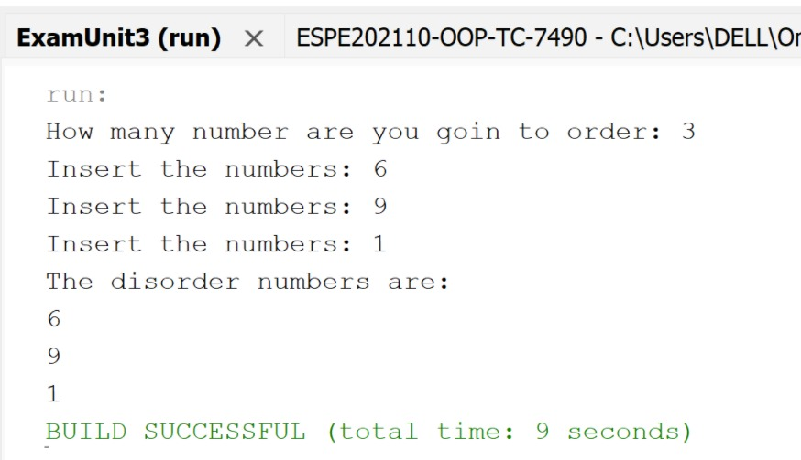

Clean code/principles

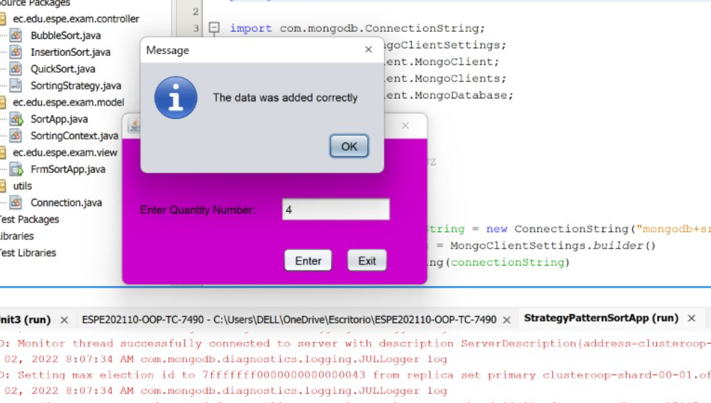

JSON MongoDB

